31.17: a) 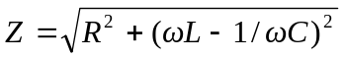
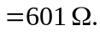
b) 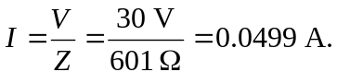
c) 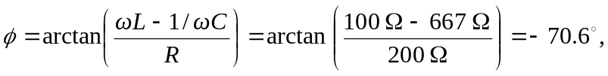 and the voltage lags the current.
d)

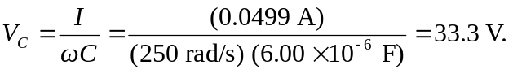
e) Because of the charge-storing nature of the capacitor, its voltage will tag the source voltage. That is, the capacitor’s voltage will peak after the source voltage.

